MATHEMATICS DEPARTMENT 2015
Year 11 Specialist - Test Number 5
Trigonometric Identities and Complex Numbers


Name: ____SOLUTIONS_______________________ Teacher: DDA
Marks: 50
Time Allowed: 45 minutes
Instructions: You are permitted 1 page notes but no calculator.
_________________________________________________________________________
Part A
8 multiple-choice questions
1 mark each: 8 marks
Circle the correct answer.
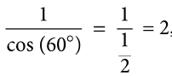
1 sec (60°) =
A 2
B
C
D
E
[1 mark]
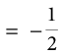
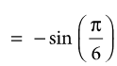
2 sin =
A −2
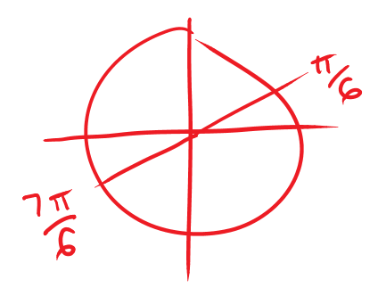
B
C
D
E

[1 mark]
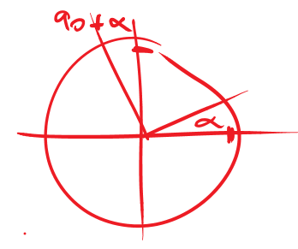
3 sin (90° + α) =
A sin (α)
B −sin (α)
C cos (α)
D −cos (α)
E sin (90°)

[1 mark]
4 The graph shown below could have the equation:
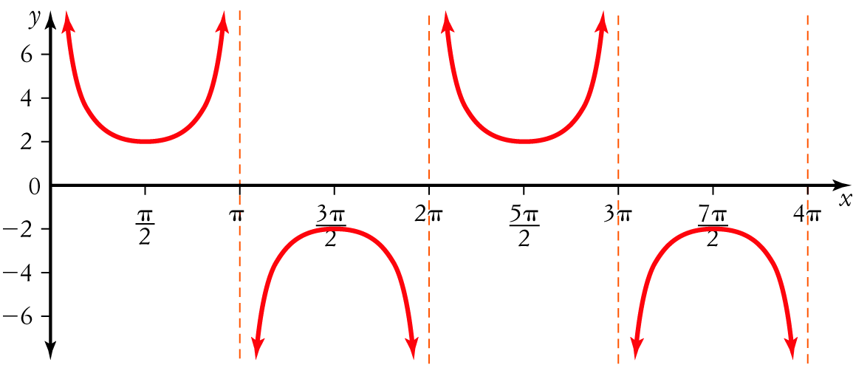
A y = 2 cosec (x)
B y = 2 sec (x − 1)
C y = cosec (x)
D y = sin (x)
E y = cosec

[1 mark]

5 mod =
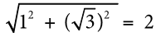
A 4
B –2
C
D 2
E 2i

[1 mark]

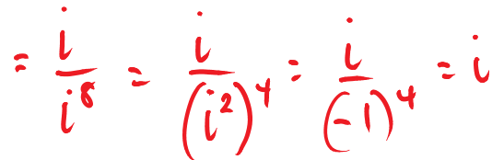
6 The value of is:
A i
B 1
C –1
D –i
E
[1 mark]

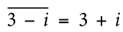
7
A 3 – i
B –3 – i
C –3 + i
D 3 + i
E 3 + 3i
[1 mark]

8 The solutions to the quadratic equation x2 + 16 = 0 are: 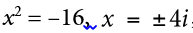
A
B ±4
C ±4i
D
E ±2i

[1 mark]

Part B
10 short answer questions
29 marks
Show your working where appropriate.

9 Express the following in the form a+bi:
[2 mark]
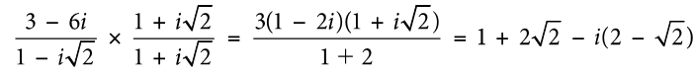

10 A quadratic equation has roots . Express it in the form $ax^{2}+bx+c=0$
[2 mark]
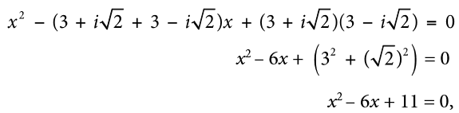

11 Sketch the graph of y = −sec (x) + 1 for 0 ≤ x ≤ 4π.
[4 marks]

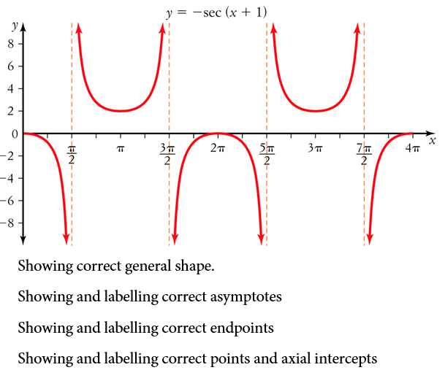

12 Using the Pythagorean identity sin2 (θ) + cos2 (θ) = 1 evaluate cos2 given that sin.

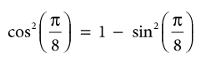
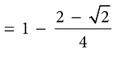
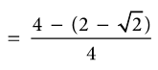
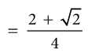

[3 marks]
13 Using a suitable compound angle formula evaluate tan .
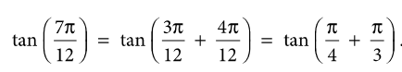
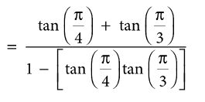
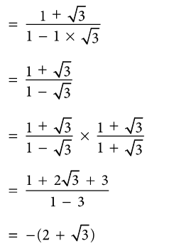
[4 marks]
14 Express cos (60°) cos (15°) as a sum. DO NOT evaluate.

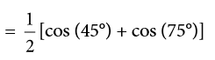
[1 mark]

15 If w = 2 – 3i, the points A, B, C and D correspond to the vectors and iw. [5 marks]
a State the coordinates of the points A, B, C and D.

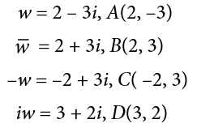

b Plot the points A, B, C and D on an Argand diagram.
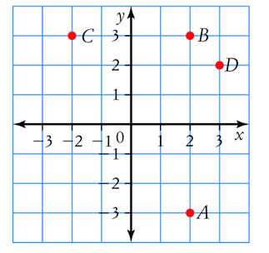

[5 marks]

16 Consider the complex numbers z = –1 + and w = .
a Find Im(z + w).
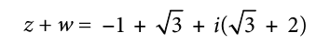
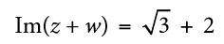

b Find Re(zw).

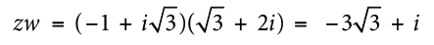
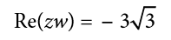
[4 marks]
17 Solve the equation x2 – 8x + 17 = 0 in the complex plane.
[2 marks]
18 Realise the denominator on , expressing your answer in the form a + bi, where a, b R.
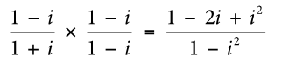
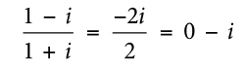
[2 marks]

Part C
3 analysis questions
13 marks
Show your working where appropriate.
19 Rewrite the expression sec (x) sin (2x) − sin (x) cos (2x) in terms of sin (x) only.

[3 marks]

20 Prove that 1 + tan2 (x) = sec (x) cosec (x) tan (x).
[3 marks]

21 Prove each of the following for z = x + yi, where x, y R:
a

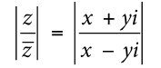
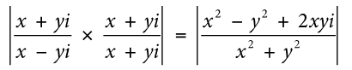
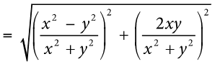
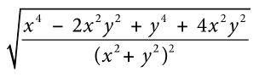
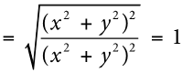
b
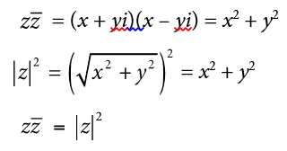

[4,3: 7 marks]
Total marks: 50

